Mighty to Save (내 주는 구원의 주)

D A F#m
Everyone needs compassion, love that's never failing
E
Let mercy fall on me
D A F#m
Everyone needs forgiveness, the kindness of a Savior
E D E D E
The hope of nations

A E
Savior, He can move the mountains
D A
My God is mighty to save
F#m E
He is mighty to save
A E
Forever, Author of salvation
D A
He rose and conquered the grave
F#m E (D A F#m E)
Jesus conquered the grave

D A F#m
So take me as You find me, all my fears and failures
E
Fill my life again
D A F#m
I give my life to follow, everything I believe in
E D E D E
Now I surrender

D A E
Shine Your light, and let the whole world see
F#m D A E
We're singing for the glory of the risen King
F#m D A E
Jesus, Shine Your light, and let the whole world see
F#m D A E
We're singing for the glory of the risen King
Used by Permission. CCLI #11103902 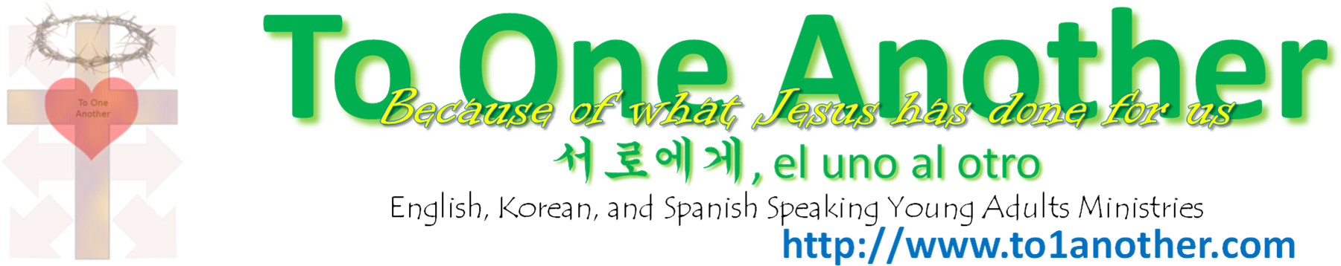

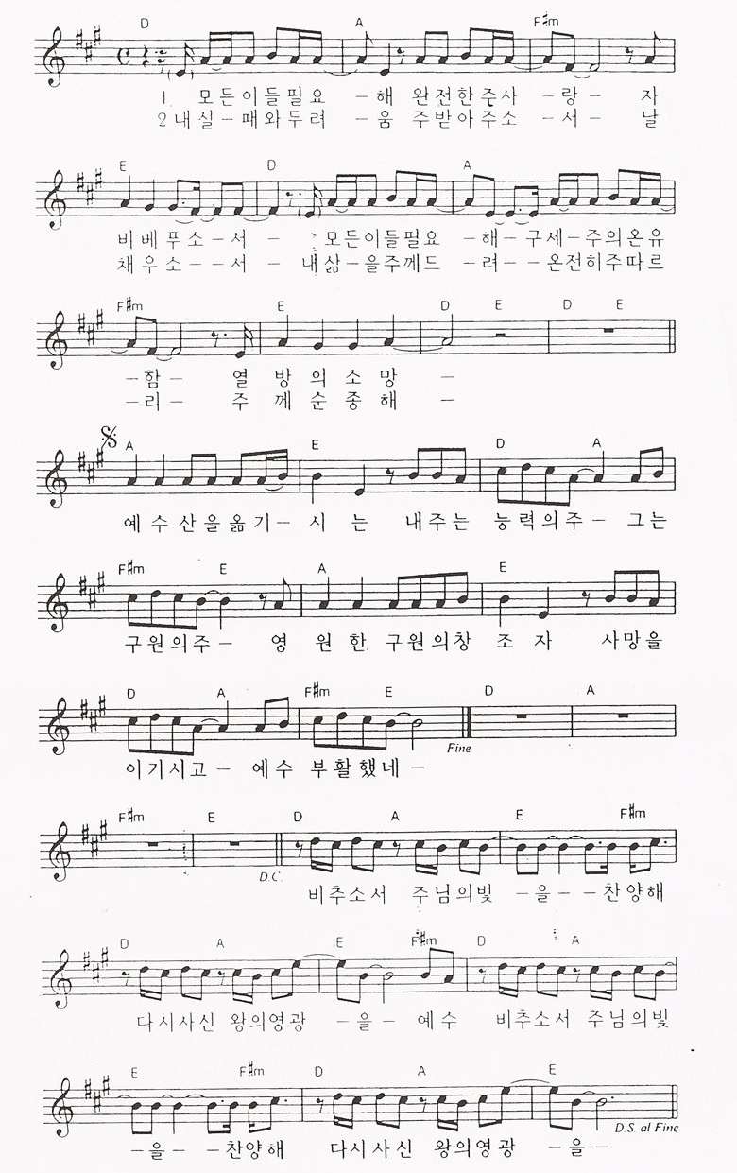
Used by Permission. CCLI #11103902

